# Strategies for a Sustainable Future in the Face of Climate Change

## Introduction

Climate change stands as one of the most pressing challenges of our time. Rising global temperatures, increasingly frequent extreme weather events, sea-level rise, and biodiversity loss are just a few of its visible consequences. These impacts pose threats not only to the environment but also to global economies, health systems, and communities. Given the severity of the problem, finding effective solutions to climate change is more urgent than ever. Addressing climate change requires a multifaceted approach that includes governmental policies, technological innovations, individual actions, and international cooperation[1-5].

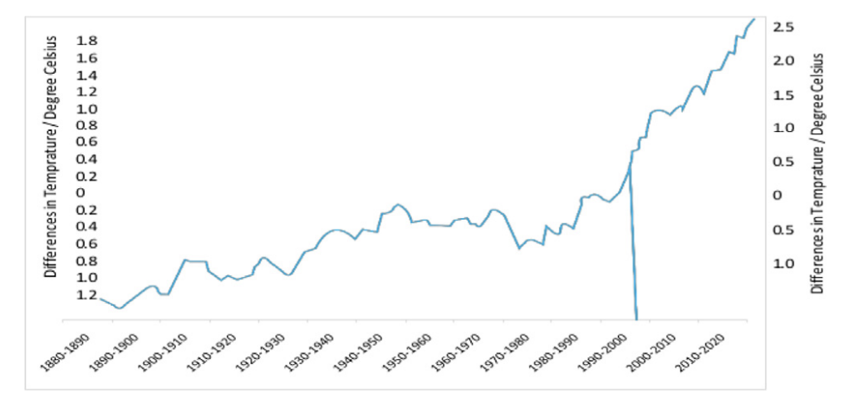

Figure 1 Global temperature fluctuated from 1880 to 2020.

## 2. The Causes of Climate Change

The ozone layer in the stratosphere protects life on Earth by absorbing 94–99% of harmful UV rays from the sun [6]. It was discovered in 1913 by French physicists Henri Buisson and Charles Fabry, and British meteorologist Dobson later developed a method for measuring ozone levels using the "Dobson meter." He also established a global network of ozone monitoring stations between 1928 and 1958, which still operates today.

Figure 2 The total global anthropogenic greenhouse gases (GHG) productions in 2010

In the 1970s, scientists discovered a "hole" in the ozone layer over Antarctica, caused by human-made chemicals, mainly chlorofluorocarbons (CFCs) [7]. These chemicals are a major cause of ozone depletion.

The ozone layer is also being affected by rising carbon dioxide (CO2) levels, driven by human activities. Greenhouse gases like CO2, methane (CH4), and nitrous oxide (N2O) contribute to global warming (IPCC, 1996). CO2 is the primary cause of climate change. The COVID-19 pandemic led to a temporary decrease in CO2 emissions, but overall, CO2 levels have increased by 25% in the past 125 years [8]. Climate change anxiety is growing, with more people feeling concerned about its effects. The main sources of CO2 emissions come from human industrial activities.

Since the Industrial Revolution, CO2 levels have risen by over 30%, from 280 ppm in 1700 to around 380 ppm in 2000. Before industrialization, CO2 levels remained stable for over 1,000 years.

## 3. Effective Solutions at Different Levels

## 3.1 Policy and Governmental Measures

One of the most important ways to combat climate change is through strong governmental and policy measures. Governments play a crucial role in shaping regulations that limit greenhouse gas emissions and promote sustainable development. For instance, the implementation of carbon pricing mechanisms such as carbon taxes or cap-and-trade systems can incentivize industries to reduce emissions. Setting strict emission standards for vehicles, factories, and power plants also helps in curbing pollution. Furthermore, investing in green infrastructure—such as clean public transportation, energy-efficient buildings, and reforestation projects—can significantly contribute to emission reductions while supporting sustainable growth[9].

## 3.2 Technological Innovations

Technology also plays a vital role in climate change mitigation. A major solution lies in the transition from fossil fuels to renewable energy sources. Solar, wind, hydro, and geothermal energy offer clean alternatives that can power homes, industries, and transportation without emitting carbon dioxide. In addition, improving energy efficiency through advanced technologies such as smart grids, LED lighting, and high-performance insulation can reduce energy consumption. Another emerging technology is carbon capture and storage (CCS), which allows the removal of CO₂ from the atmosphere or directly from emission sources, storing it underground safely[10].

## 3.3 Nature-Based Solutions

Nature-based solutions (NbS) are ways to solve social and environmental problems by working with nature. Recently, they have become popular because they can help fight climate change, protect biodiversity, and support sustainable development. While NbS can offer many benefits, most attention has focused on planting trees to absorb carbon. This focus raises concerns. It may distract from the urgent need to stop using fossil fuels and to protect existing natural ecosystems. There are also worries that expanding forests for climate goals may harm carbon-rich native ecosystems and take away resources from local communities[11].

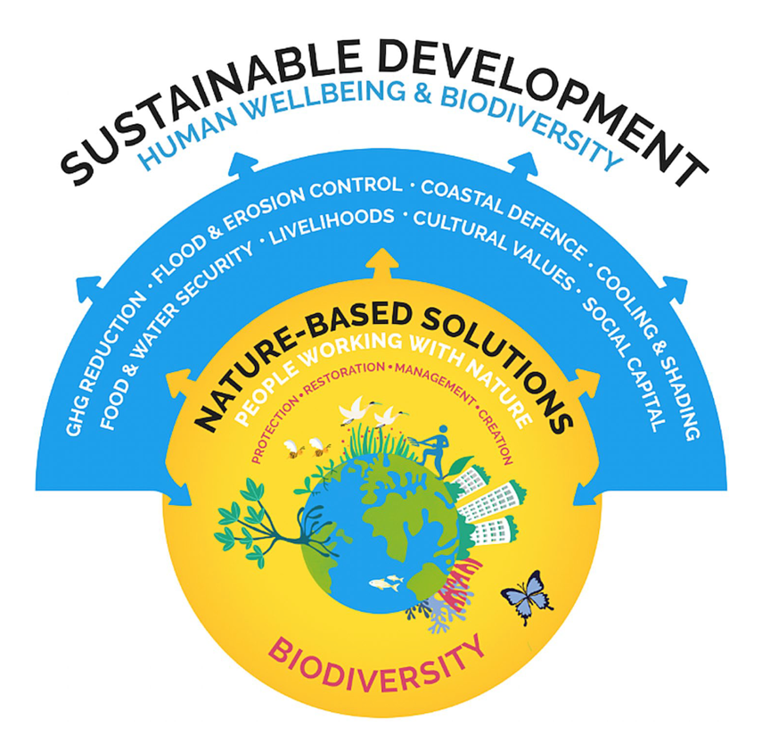

Figure 3 Conceptual diagram of nature- based solutions.

## 4. Challenges and the Way Forward

Despite progress, challenges remain. Developing and deploying green technologies require large investments. Political resistance, economic disparities, and lack of awareness in some regions slow down global action. Furthermore, international cooperation is difficult due to competing national interests[12].

However, there are reasons for optimism. Climate education is improving, green jobs are increasing, and youth-led climate movements are putting pressure on decision-makers. Turning these trends into lasting change requires continued public support and political will.

## 5. Conclusion

In conclusion, climate change is a complex and global challenge that demands a comprehensive and coordinated response. Governments must create and enforce effective environmental policies; innovators must develop and deploy green technologies; individuals must embrace sustainable habits; and nations must work together in unity. The future of our planet depends on our collective actions today. While the road ahead is long, the solutions are within reach if we act with urgency, cooperation, and commitment. Each of us, in our roles, has a part to play in securing a livable and sustainable future for generations to come.

## Reference

[1]  Devine-Wright, P. & Quinn, T., Dynamics of place attachment in a climate changed world. *Place Attachment*, pp. 226–242, 2020.

[2]  Abel, D.W. et al., Air-quality-related health impacts from climate change and from

adaptation of cooling demand for buildings in the eastern United States: An interdisciplinary modeling study. *PLOS Medicine*, 15(7), e1002599, 2018.

[3]  Karimi, V., Karami, E. & Keshavarz, M., Climate change and agriculture: Impacts and adaptive responses in Iran. *Journal of Integrative Agriculture*, 17, pp. 1–15.

[4]  Luo, M., Sa, C., Meng, F., Duan, Y., Liu, T. & Bao, Y., Assessing extreme climatic changes on a monthly scale and their implications for vegetation in Central Asia. *Journal of Cleaner Production*, 271, 122396, 2020.

[5]  Irby, I.D., Friedrichs, M.A., Da, F. & Hinson, K.E., The competing impacts of climate change and nutrient reductions on dissolved oxygen in Chesapeake Bay. *Biogeosciences*, 15(9), pp. 2649–2668, 2018.

[6] Albritton, Daniel. "What Should be Done in a Science Assessment." *Protecting the Ozone Layer: Lessons, Models, and Prospects*. Boston, MA: Springer US, 1998. 67-74.

[7] Kabir, Muhammad, et al. "Climate change due to increasing concentration of carbon dioxide and its impacts on environment in 21st century; a mini review." *Journal of King Saud University-Science* 35.5 (2023): 102693.

[8] Kabir, Muhammad, et al. "Climate change due to increasing concentration of carbon dioxide and its impacts on environment in 21st century; a mini review." *Journal of King Saud University-Science* 35.5 (2023): 102693.

[9] Salvador, Miquel, and David Sancho. "The role of local government in the drive for sustainable development public policies. An analytical framework based on institutional capacities." *Sustainability* 13.11 (2021): 5978.

[10] Shaw, Rohit, and Soumyajit Mukherjee. "The development of carbon capture and storage (CCS) in India: A critical review." *Carbon Capture Science & Technology* 2 (2022): 100036.

[11] Osaka, Shannon, Rob Bellamy, and Noel Castree. "Framing “nature‐based” solutions to climate change." *Wiley Interdisciplinary Reviews: Climate Change* 12.5 (2021): e729.

[12] Joshi, Harshita, et al. "Climate Change: The Impact and Exploring The Path Forward." *2024 International Conference on Intelligent and Innovative Technologies in Computing, Electrical and Electronics (IITCEE)*. IEEE, 2024.

## Statement

Using ChatGPT to optimize language

